Node Package Manager(npm)

Part - I : Installation of node package manager

Download the binary as shown in the below pic

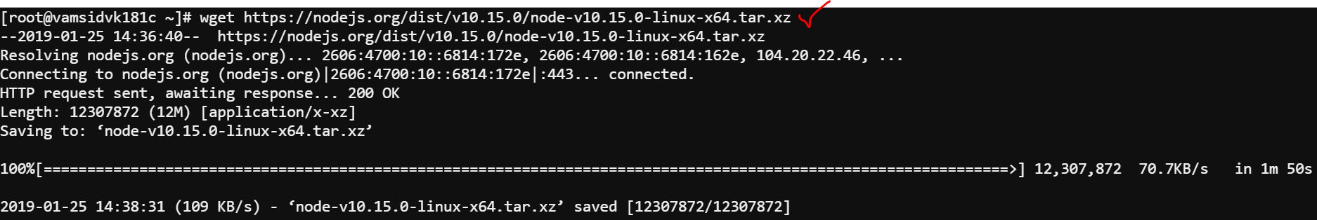

Downloaded file

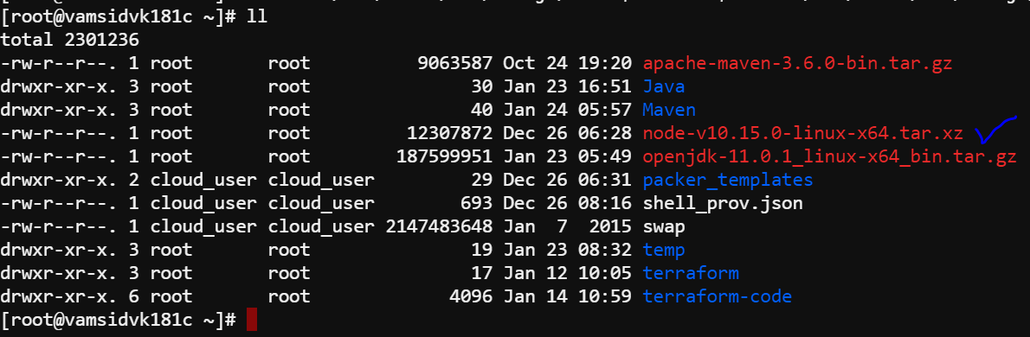

Replace variables in the below pic based the distribution binary downloaded

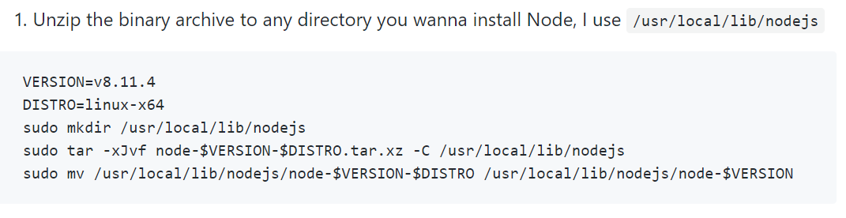

Next export the node binary path into the env variables as below

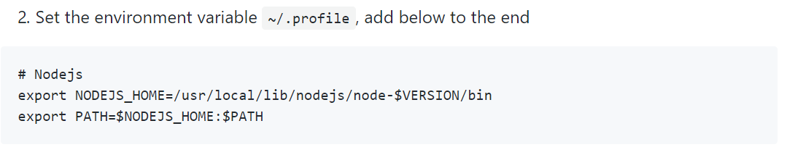

Source the bash_profile as below

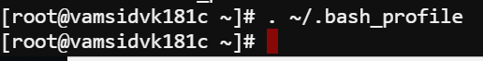

Testing the installation as below

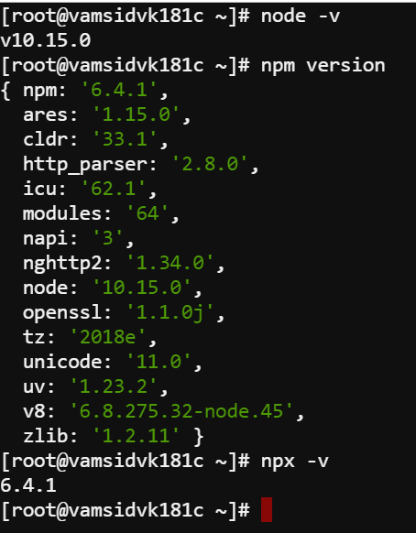

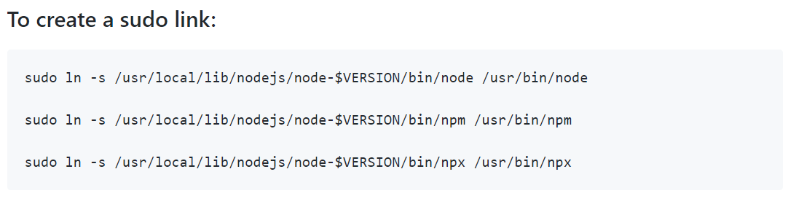

Part II – Initialize the Project

Before we do anything about the npm we need to initialize the project with npm init command and provide few details based on the input as below

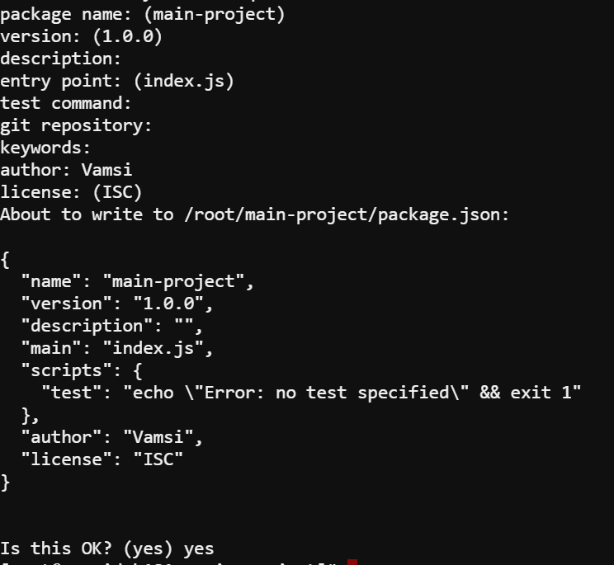

Below is the package.json file generated from the above command

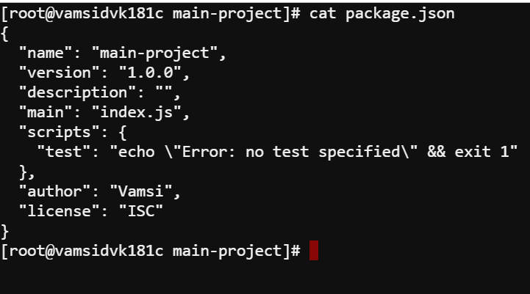

Semantic Versioning(sem Ver) of the packages :

Each package must have unique name and version , when you update the package the version needs to be updated

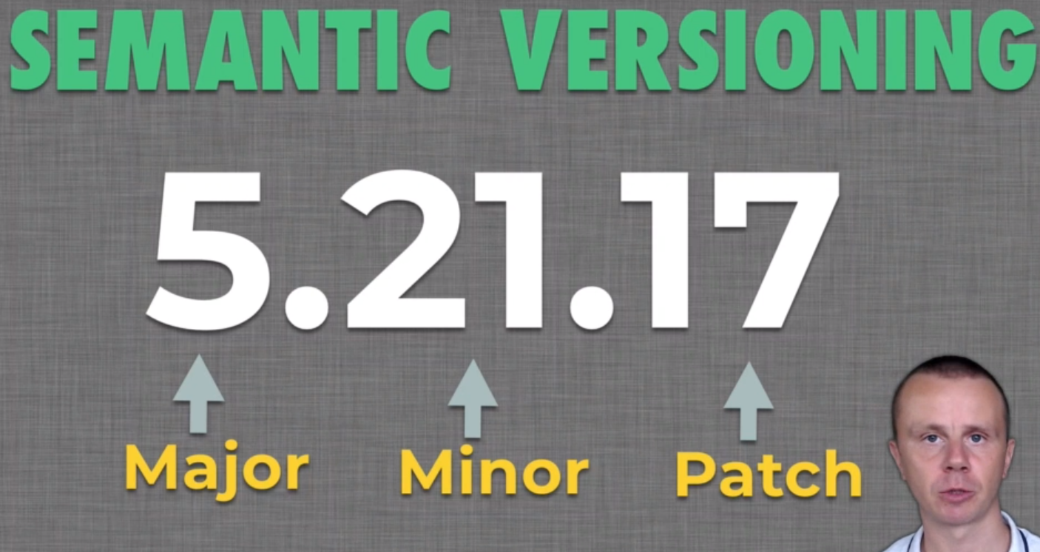

Patch – Bug fixes comes into this category

Minor – Few s/w updates

Major – Major upgrades to the software

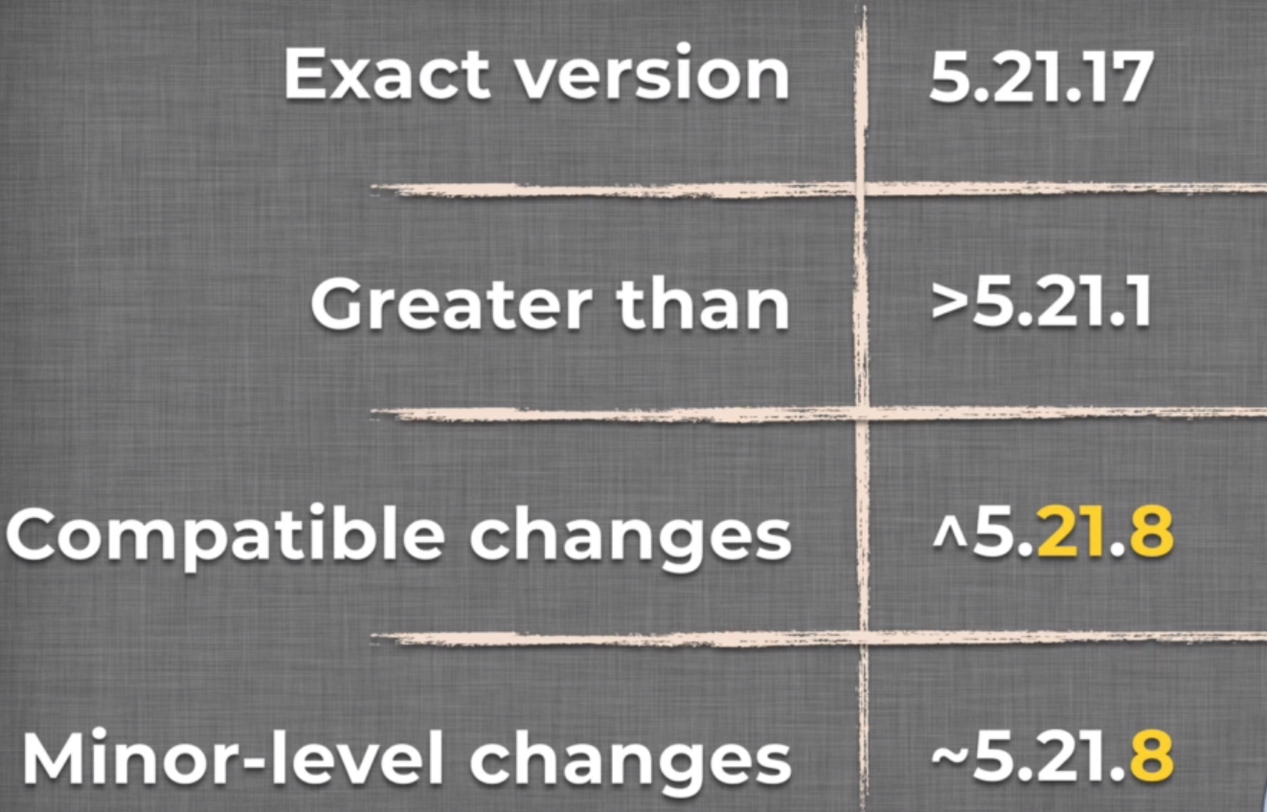

To understand above Please go through this link <https://www.npmjs.com/package/semver>

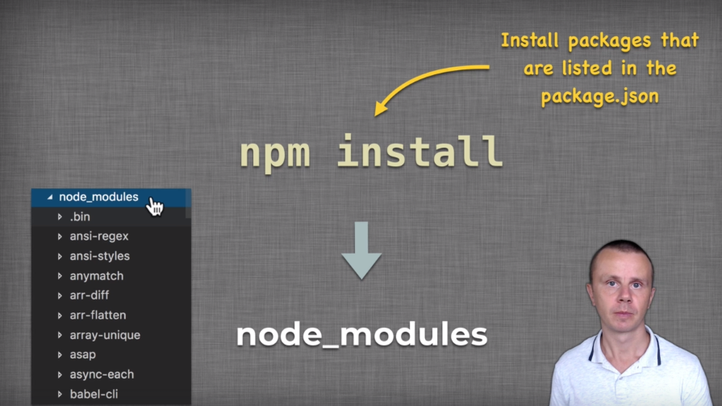

Npm install command would download the packages to node_modules folder

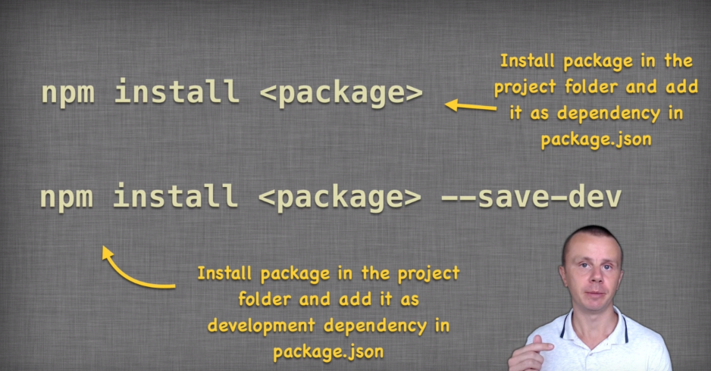

Installed in the node_module folders

Installation of a package:

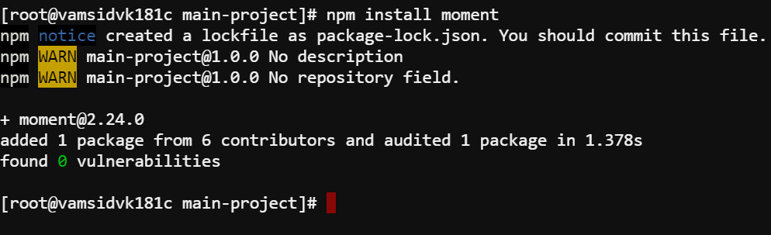

We use npm install command to download a package and add the dependency into the package.json file as below

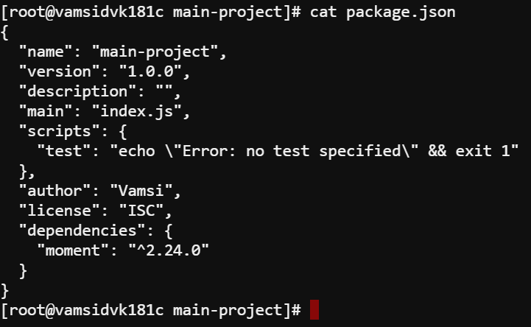

We can see there is another file added into the same directory which is package-lock.json which lists out the contents of the downloaded packages as below

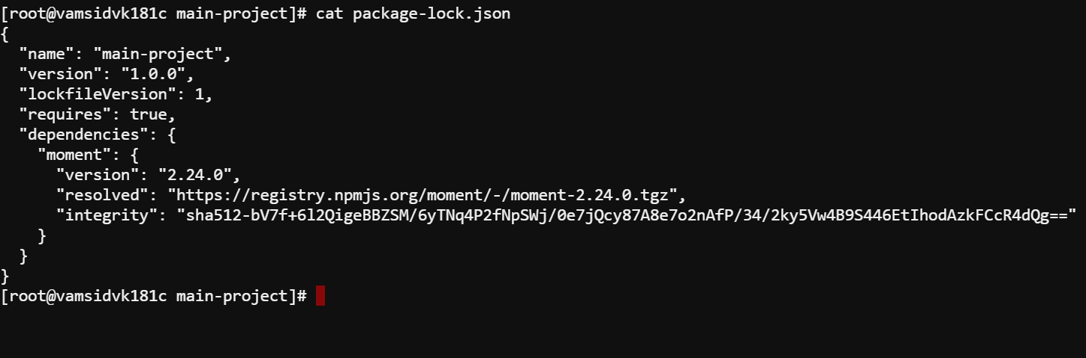

The packages gets installed into node_modules folder then we can utilize those packages into out js code through require in the initial section of the code file

Current state of the package.json after we manually installed few packages through cli

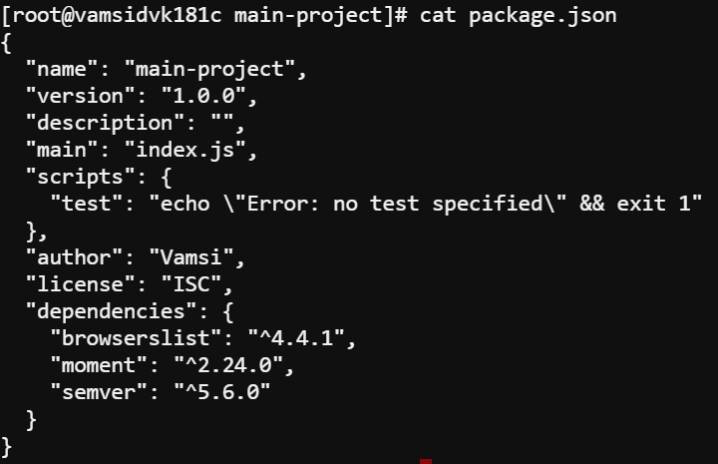

Now we have differentiate b/w dependencies and dev dependencies



What is dependency ?

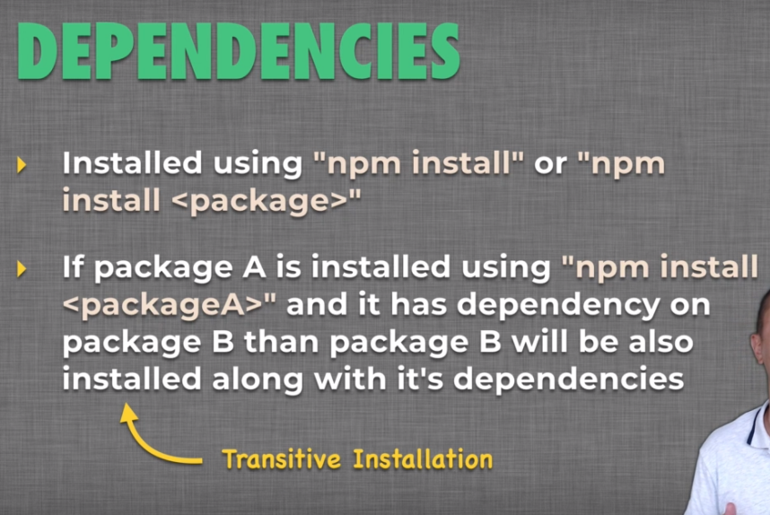

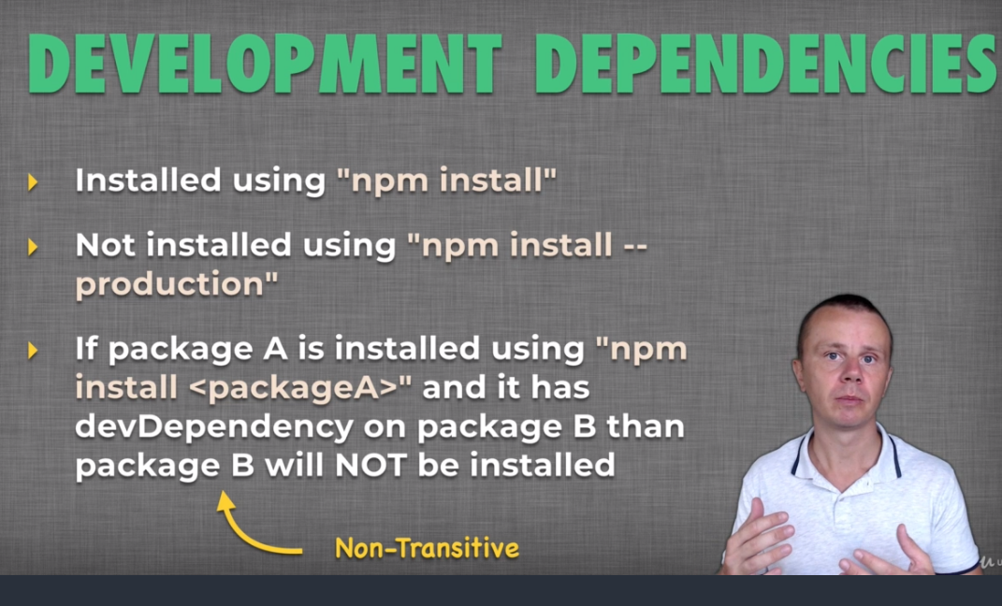

Next we un installed one of the package we installed earlier as below and final package.json file

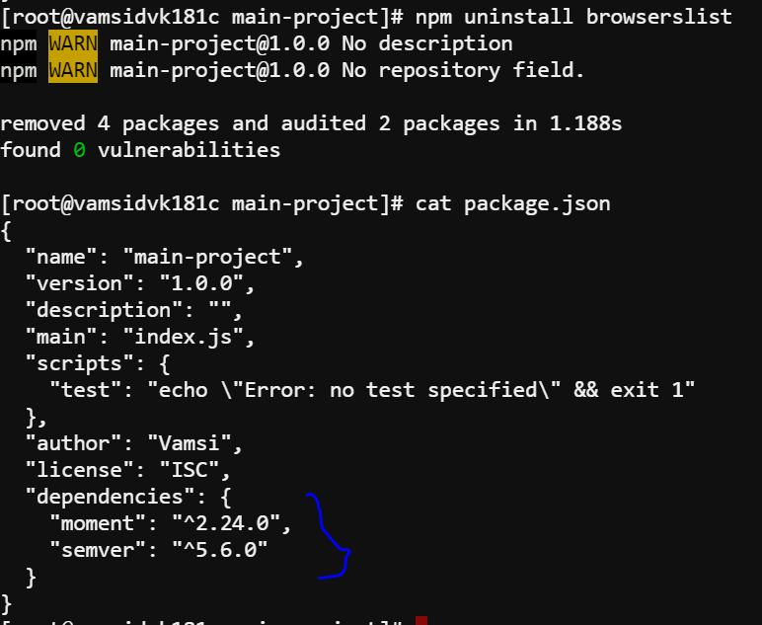

Lets install a package as dev dependencies

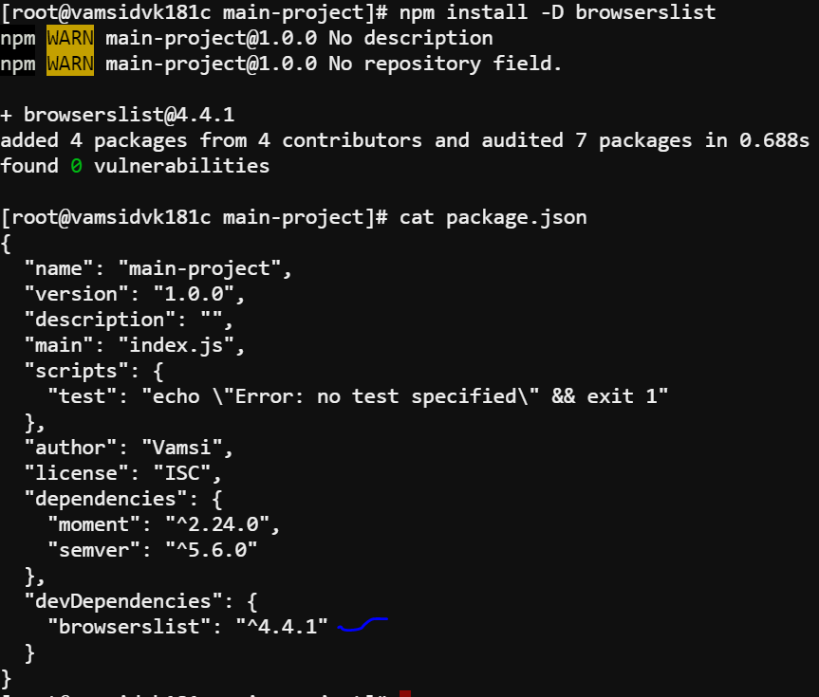



Here is the link for explanation above question

<https://stackoverflow.com/questions/18875674/whats-the-difference-between-dependencies-devdependencies-and-peerdependencies>

If the application is an webapp then the packages can reside in any section dependencies and dev dependencies . But if you’re building the package to share it to public then devdepencies must be provided to be projected as a compiled package to the public

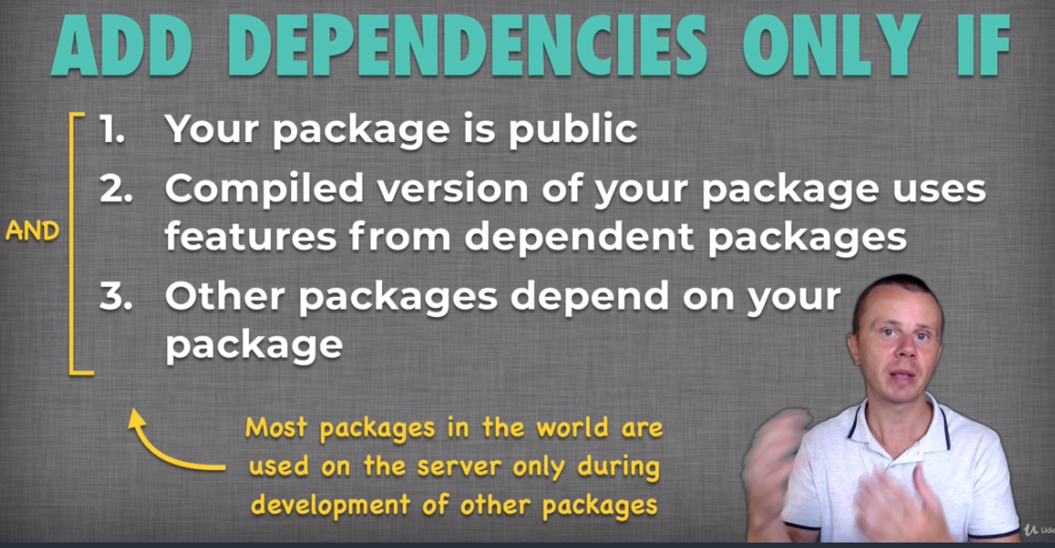

Npm commands:

npm view : to view the package info as below

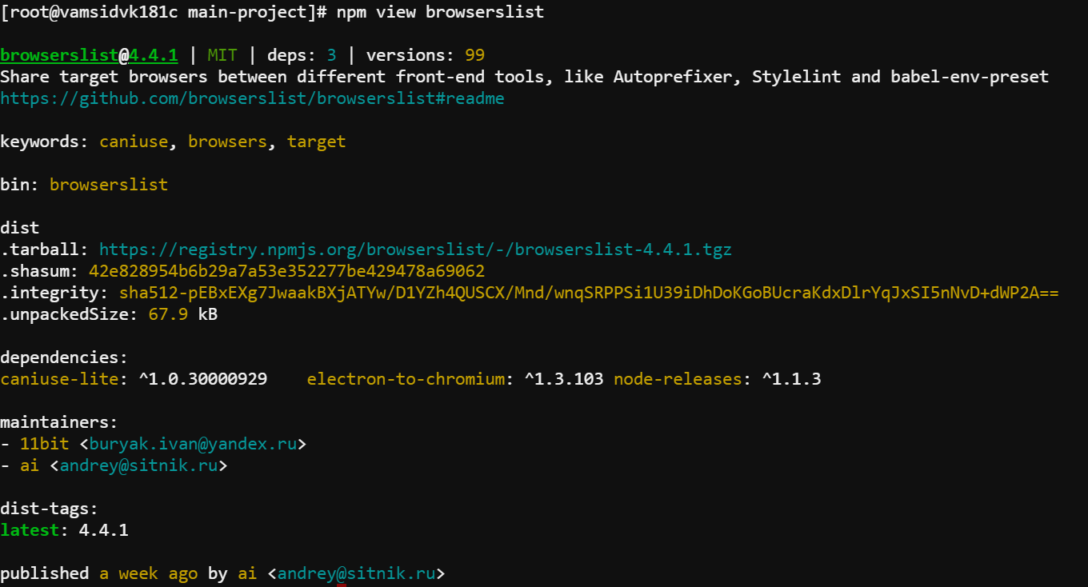

Install Specific package version : npm install <package-name> @<version>

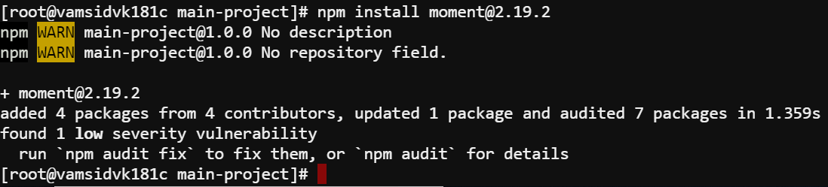

To view security vulnerabilities

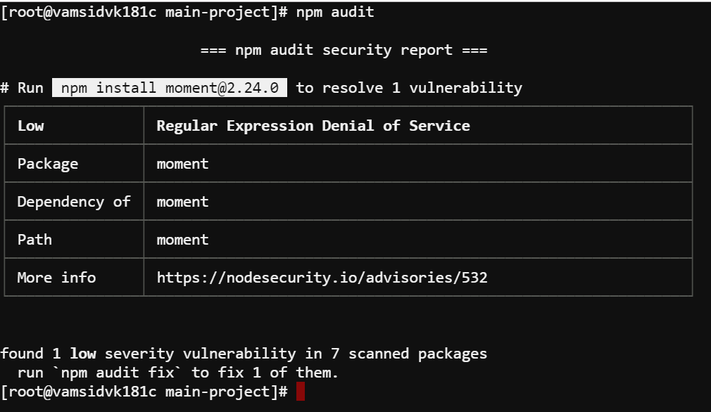

For the explanation package-lock.json file please go through below link

<https://medium.com/coinmonks/everything-you-wanted-to-know-about-package-lock-json-b81911aa8ab8>

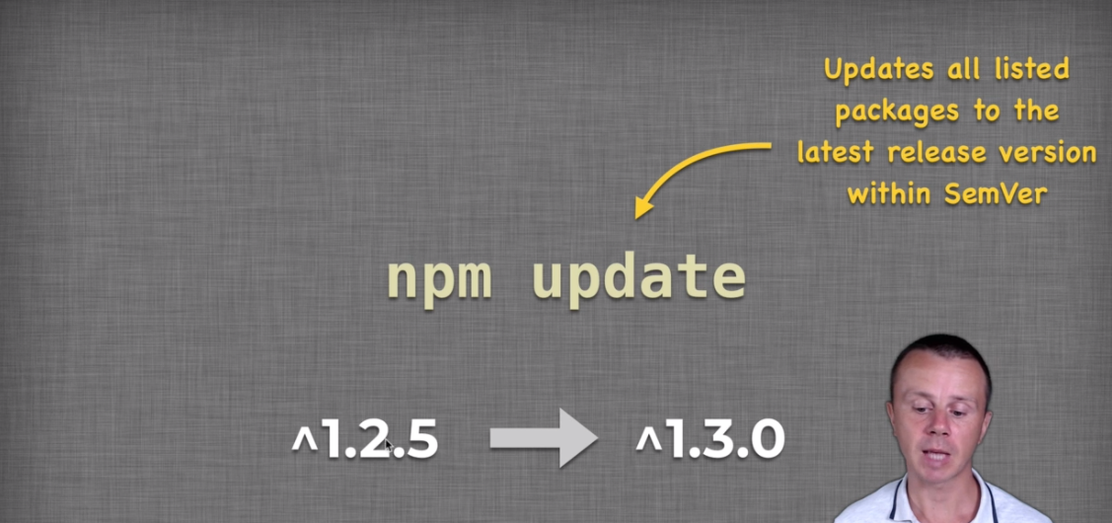

NPM scripts :

Example script section

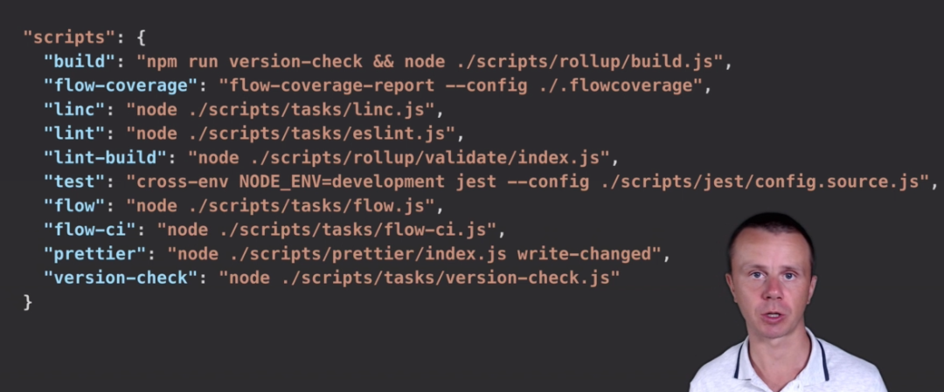

There are two kinds of scripts built in and custom scripts In our projects we use custom scripts as well as built in scripts provided by the package

We can execute the scripts using npm run <script>

In the github link we attached few files go through it